St. Thomas Church of England Primary School
Proposed spend of Pupil Premium 2020 – 2021

The pupil premium provides funding for children:
• Who have been in receipt of free school meals at any point during the last 6 years (£1320)
• Who have been previously looked after, subject to a special guardianship order and/or adopted from care (£1900 per child)
• Pupil premium plus children currently being looked after or are in care (£1900 per child per academic year held by the LA Virtual School Head accessed via PEP meetings
There is also an extra £400 available per child which can be applied for via the PEP.
• Whose parents are currently serving in the armed forces (£300 per child)
Schools are held accountable for spending these funds, performance tables will capture the achievement of children covered by Pupil Premium.
Our school is committed to providing effective resources and ensuring support is in place for our disadvantaged children to improve their academic outcomes.
Proposed funding for 2020/21 is £ 105,600

It is important to understand the challenges our deprived children face. There are a considerable number of barriers to learning including: cultural differences, poor language and communication skills, low self-confidence and social anxiety, emotional and behavioural difficulties. In addition 23% of our pupil premium children are known to have additional needs. The majority of these needs lie in the area of communication and interaction, some are within cognition and learning and a few are within the SEMH area of need. The challenges facing each child are unique to that child and there is no magic fix for these challenges. The needs of our deprived pupils are considered separately. Information regarding each pupil is gathered from a range of sources which helps to identify the needs and informs how spending may be used appropriately to improve performance and ‘close the gap’ with children from more affluent backgrounds.

There will be a brief review in December 2020 and April 2021 and then an overall review in July 2021

Our key objectives are
Priority 1- Curriculum Review and Development (2 year)
To review our current practice and identify strengths and areas for development.
Underpin the whole curriculum through Intent, Implementation and Impact relevant to our context.
Develop the appropriate skills and subject knowledge set out in the National Curriculum and programmes of study.
Clear understanding of curriculum progression in subjects through tightly focussed action plans in place.

Priority 2- To raise the attainment in KS1 at least in line with the Greater Depth National Average in Reading, Writing and Maths.
Identify areas through the curriculum review and data analysis.
Knowledge and understanding based on the progression statements from Nursery through to End of Key stage 1.
Teach greater depth skills and provide opportunities for ownership of own learning.

Priority 3- To review of English pedagogy in order to provide an English Curriculum that is focussed on language acquisition and development.
To review the current practice and identify strengths and areas for development in Reading and Writing– Audit.
To implement a programme of study in line with National expectations – Spellings To improve handwriting across the school. Increase the number of children reaching National Average in Reading end of Key stage 1 and Key stage 2.
Further develop oracy strategies across school.

Priority 4- PSHE
Implement the new Relationship and Health Education in line with statutory requirements.
Identifying current practice and resource audit.
Ensure CPD training opportunities are available for all staff.

Priority 5 – Ensure our Curriculum review reflects the Church of England distinctiveness of St Thomas’
Ensure Christian Values are embedded across the curriculum.
Review whole school ethos, ensuring it reflects our school vision and mission.

Objective 1 Teachers will implement and build on strategies taught within interventions and be able to measure the impact of the intervention enabling pupils to use the skills learned in class.
Action: Targeted support directed by the class teachers in all classes in the key areas of the curriculum. The class teachers will feed back to the children daily. (Due to COVID restrictions every class will be a bubble at least for the Autumn term) Each bubble will have a class teacher and a TA/SSA to support and deliver relevant interventions- reviewed December 2020
Rational:
Teaching and learning Toolkit (EEF) indicates that Feedback has a high impact on performance. Research indicates (Blooms Mastery Learning) indicates that feedback to learners tends to have a positive impact.
Success Criteria: Pupils will receive the support they need which will enable them to access the appropriate area of the curriculum and be working towards ARE
Date | Person Responsible | Monitoring and evaluation | Cost
Sept 2020 | Class Teachers and all relevant TAs/SSAs  Base line assessments administered during first few days of term PIRA/PUMA/GPS  To yr 1/2/3/4/5/6  Nursery & Reception Wellcomm assessment | CM/YA/KM/LN  Termly progress meetings  Review and set IEPs every term  Team leaders to monitor intervention progress.  SENCo to report to SLT  Targets on Edukey provision map | £40000  £2000

All children were base lined the first few days in September as school had been closed to the majority of pupils since 23rd March 2020 due to COVID. School remained open for Key worker children and vulnerable children throughout. Nursery, Reception, Year 1 and Year 6 were invited back to school on June 1st. September 1st all children were invited back to school and assessments were done to baseline the children.
September 2020 Nursery, Reception, Year 1 Wellcomm
Year 1-6 PIRA, PUMA GPS- establish starting points for PP children. KM to drill down to see where gaps are in each class. KM to have meetings with class teachers to discuss strategies/interventions to be employed in class to help our children plug the gap.
Year 1 AA/LH WB 28TH Sept 2020 – details added to the Edukey Provision map
Year 2 CDM/AM WB 5TH Oct 2020
Year 3 MB/ AMc/JM 12TH Oct 2020
Year 4 LD/DB 19th Oct 2020
Year 5 LK/VKD 2nd Nov 2020
Year 6 DM/SK 9th November 2020
October 2020 IEPs evaluated and reset.
Impact will be measurable at next PIRA PUMA assessment and SATS assessment in yrs 2 and 6
Impact of Objective 1-December Review 2020
Meetings were implemented with class teachers. They discussed the possibility of interventions which is difficult with everyone needing to stay in bubble. Interventions to run in classroom with adults in the class.
RDW reception-These scores were the baseline in Autumn 1
- 32% of the new intake have language skills within age related expectations for their chronological age.
- 36% of the cohort have language skills below age related expectations.
- 23% of the new intake have moderately delayed language skills.
9% of the reception pupils have significantly delayed language skills
RSM reception
- 4% of the new intake have language skills within age related expectations for their chronological age.
- 44% of the cohort have language skills below age related expectations.
- 22% of the new intake have moderately delayed language skills.
- 30% of the reception pupils have significantly delayed language skills.
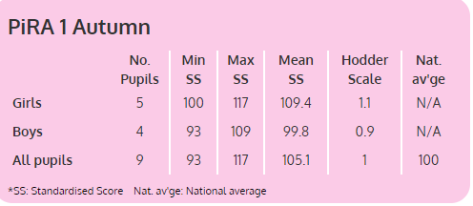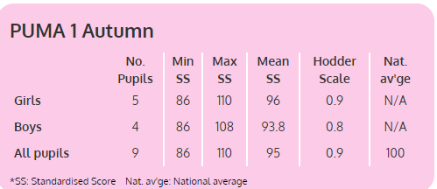
Year 2- Pupils completed Summer 1 in September 2020 directly after fist lockdown

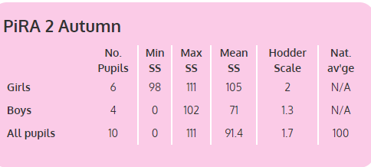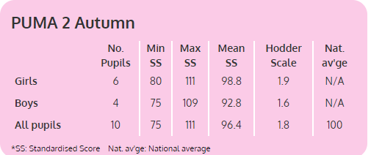

Year 3 Pupils
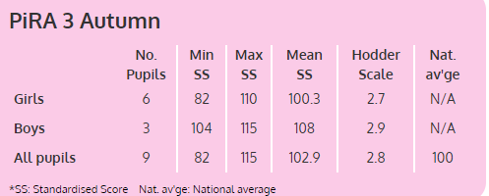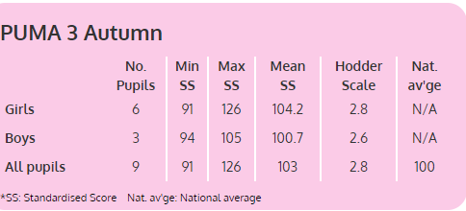

Year 4
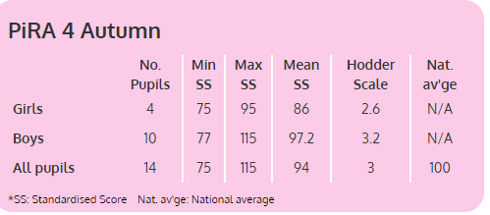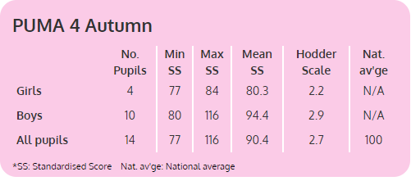

Year 5
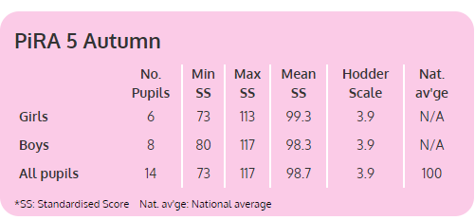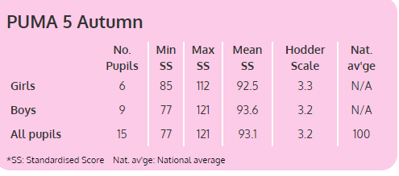

Year 6
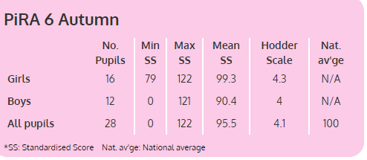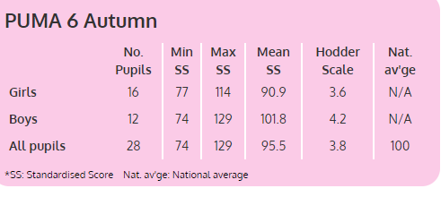

April Review 2021 – RDW 64% children now have language skills in line with ARE for the chronological age
RSM due to school closure/staff shortage the assessment will be done in Summer 2
In Nursery 56% of (AM) children now have language skills in line with ARE for the chronological age
40% of (PM) children now have language skills in line with ARE for the chronological age
Overall AM&PM&30 hours children 50% now have language skills in line with ARE for the chronological age
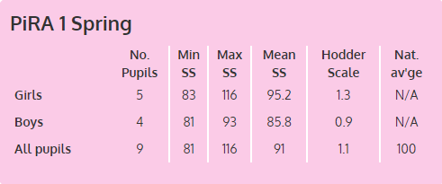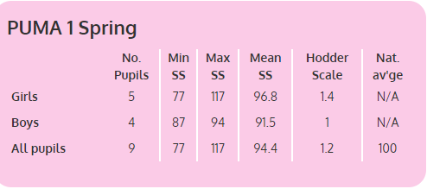
Year 2 Pupils
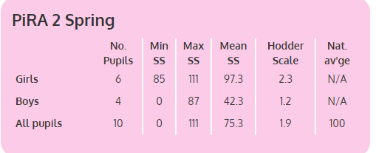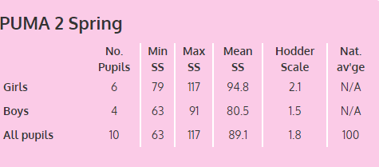
Year 3 Pupils
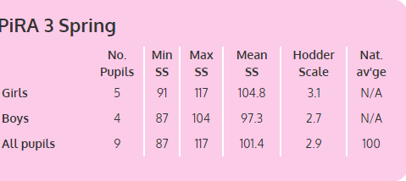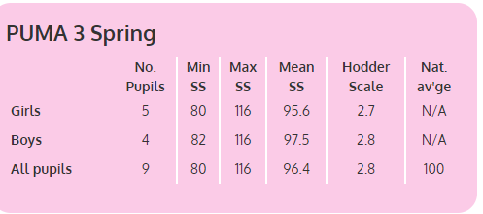

Year 4 Pupils
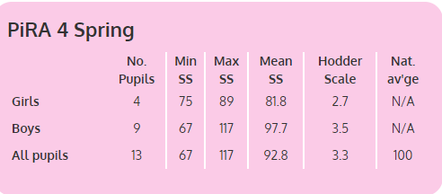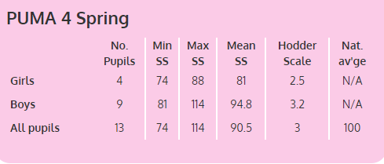

Year 5
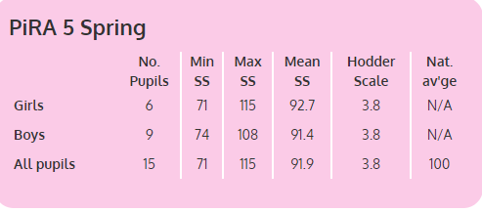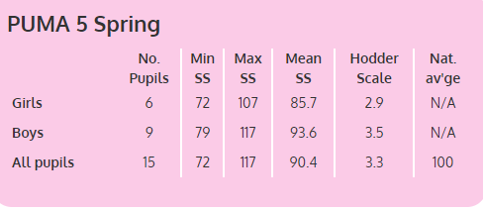

Year 6
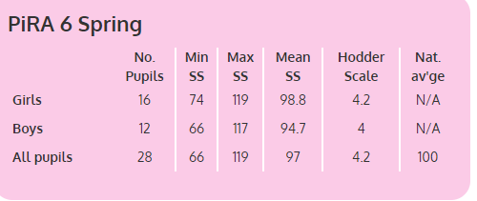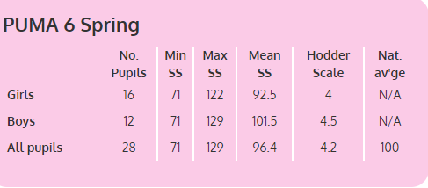

July Review 2021- Year 1 Progress of PP children over the year matched against national averages
Reading Maths
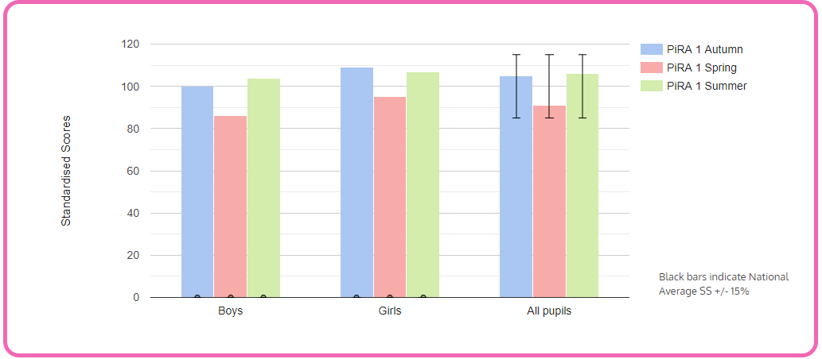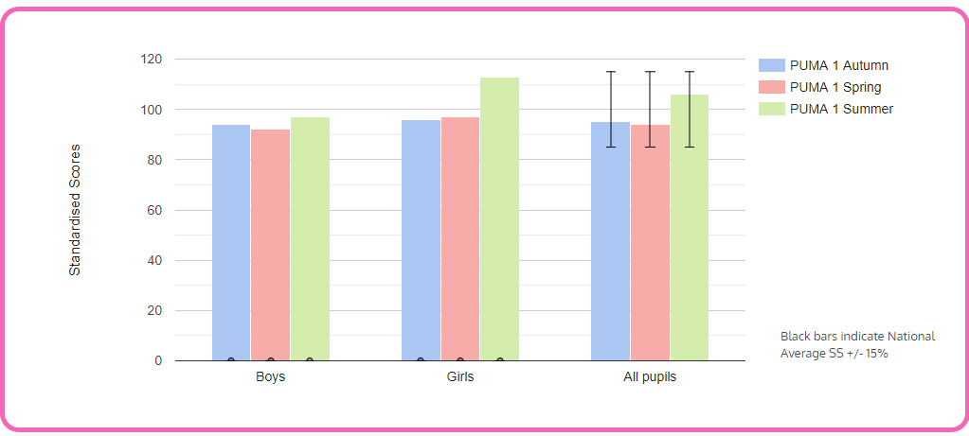

Year 2 Progress of PP children over the year matched against national averages
Reading Maths
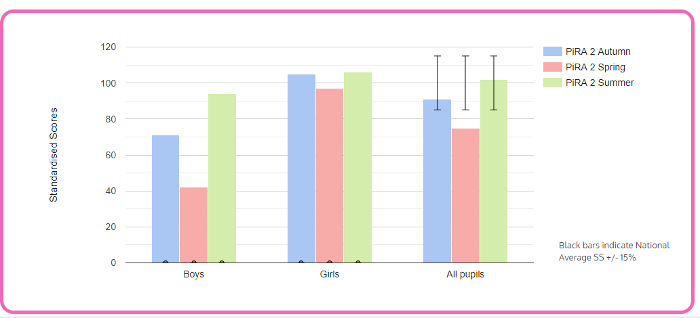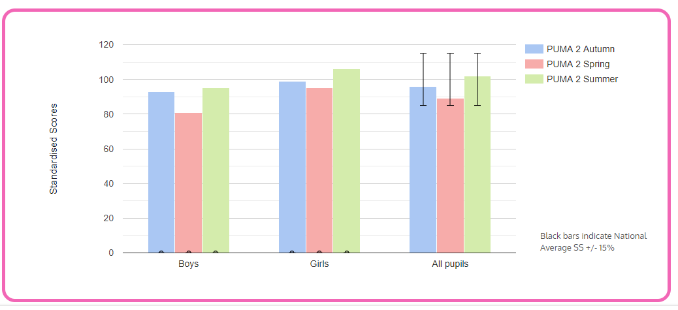
Year 3 Progress of PP children over the year matched against national averages
Reading maths
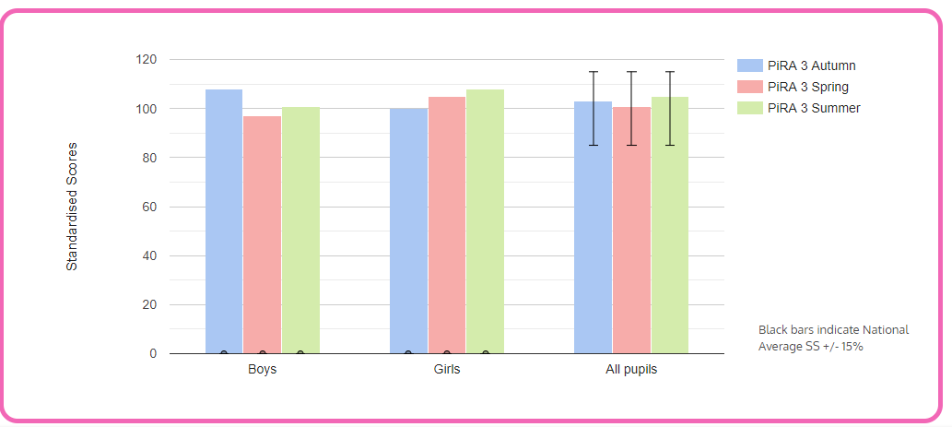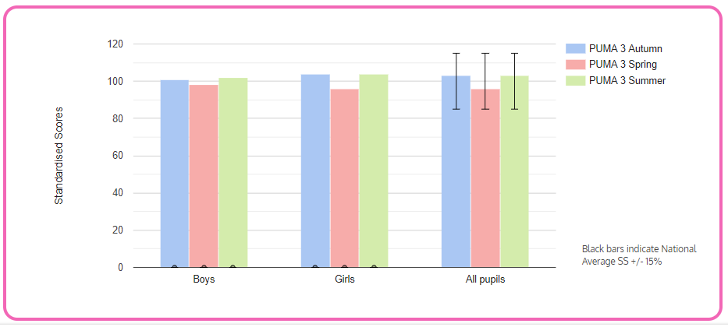

Year 4 Progress of PP children over the year matched against national averages
Reading Maths
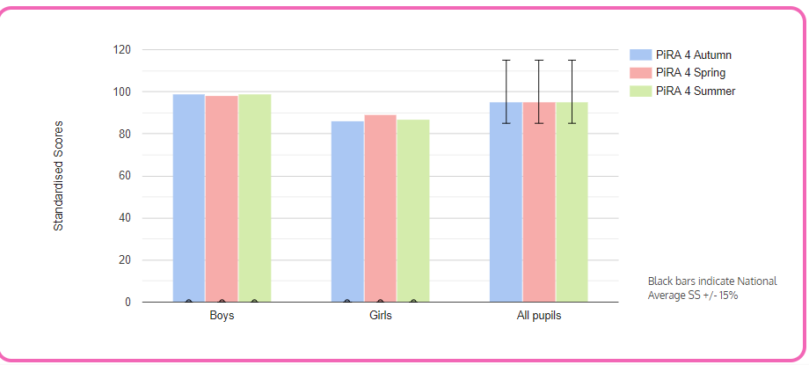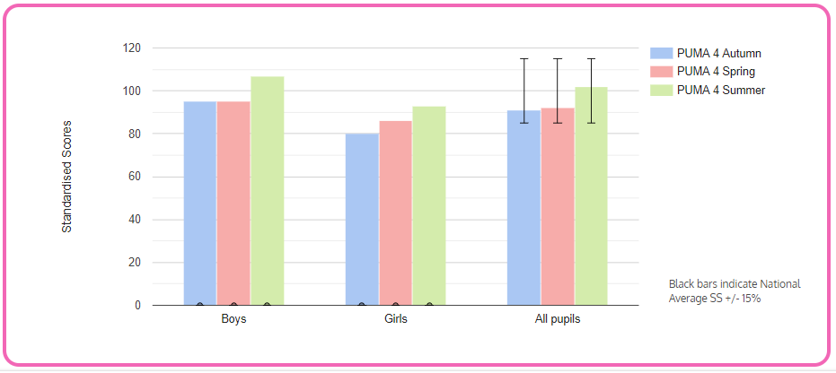
Year 5 Progress of PP children over the year matched against national averages
Reading Maths
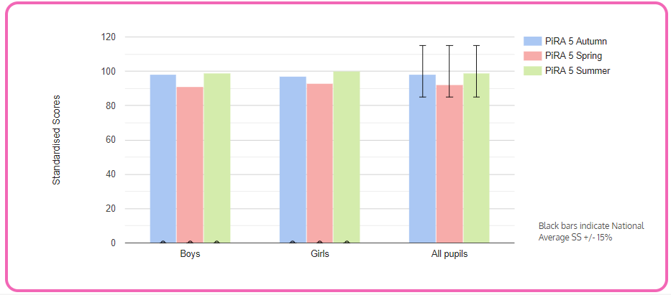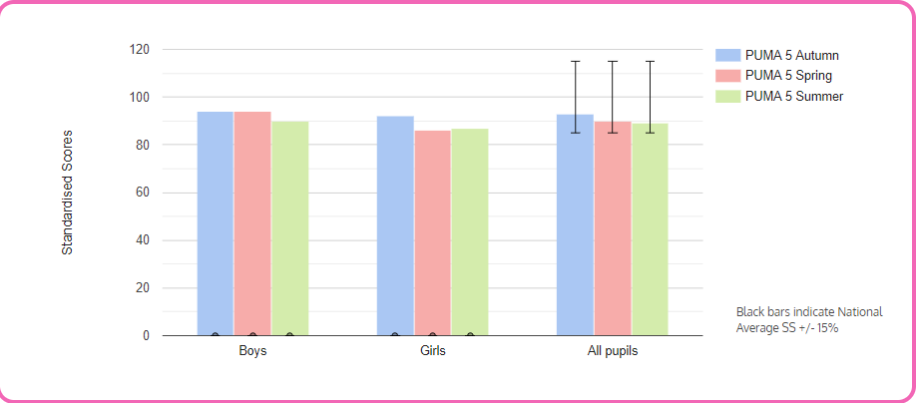

Year 6 Progress of PP children over two terms matched against national averages
Reading Maths
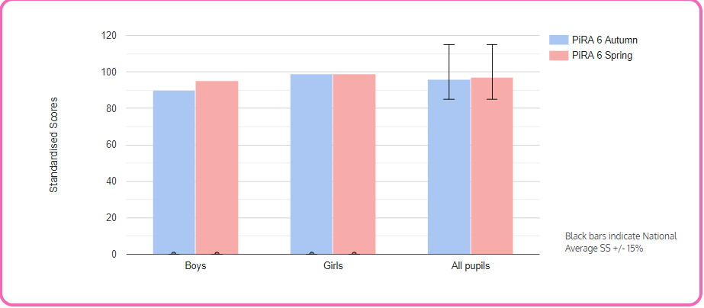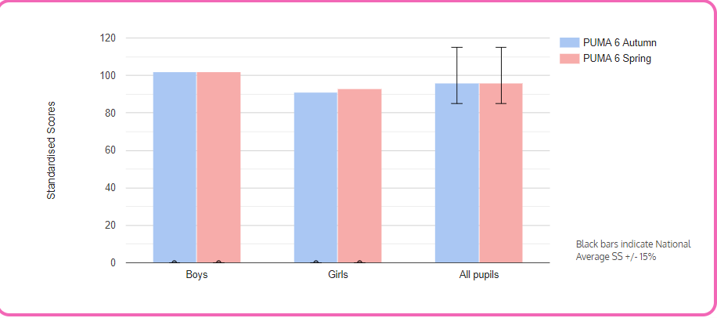
Year 6 80% of PP are at ARE or above in writing
73% of PP are at ARE or above in reading
66% of PP are at ARE or above in maths
Reception reading
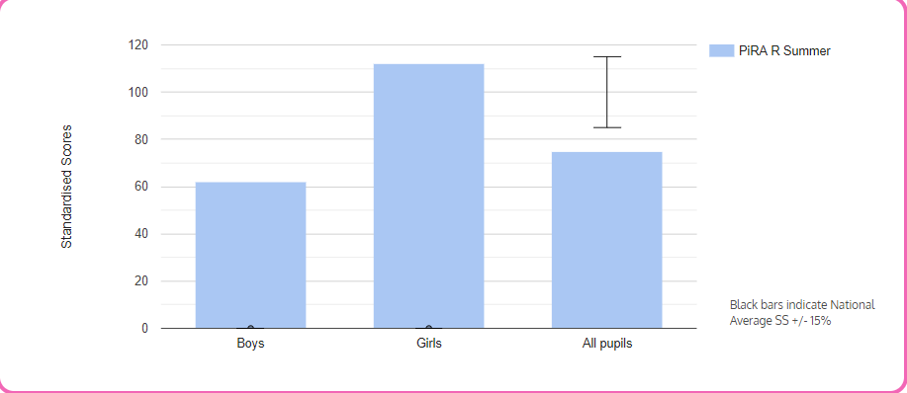
Objective 2: The language acquisition of all PP children in EYFS will be at age related expectation of 4 word level by the end of the year 2021

Action: Provide a language rich environment in Reception to develop the level of language to age related expectation.
All children are DLS assessed by class teachers and Level 3 language specialist. Provision for the development of language will follow the results of the DLS assessment and Wellcomm assessment.
NN currently working in Nursery supporting children with language –ROSCo intervention
Rationale: The underlying issue is the level of Speech and Language on entry into Reception. In Reception all children will be immersed in the English language, targeted children will be working in ROSCo, narrative groups and wellcomm big book of ideas.
Success Criteria: All PP children will be at 4 word level or above by the end of the year.
 | Person Responsible |  | Monitoring and evaluation |  | Cost
  Date
Sept 2020 | DW /SMc/CMet/NN/KW/YR |  | CM/YA/KM/LN  Termly progress meetings  Review and set IEPs every term  Team leaders to monitor intervention progress.  SENCo to report to SLT |  | £16572
Impact of Objective 2- December review 2020
NB Time to talk is not running at moment due to staffing. This intervention is recommended by SALIE and SALT to boost language acquisition. However class teacher are implementing small group interventions based on the big book of ideas from Wellcomm.
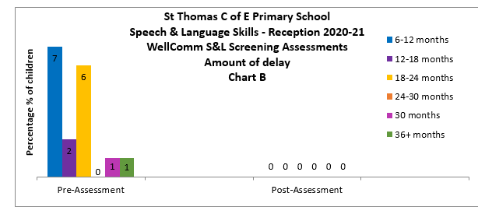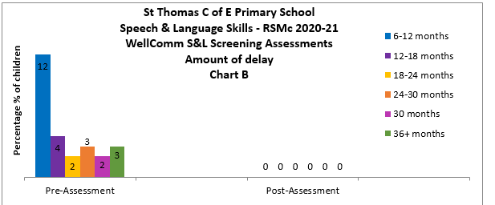

April review 2021-
School closed again in January 2021 until March 10th 21

July review 2021
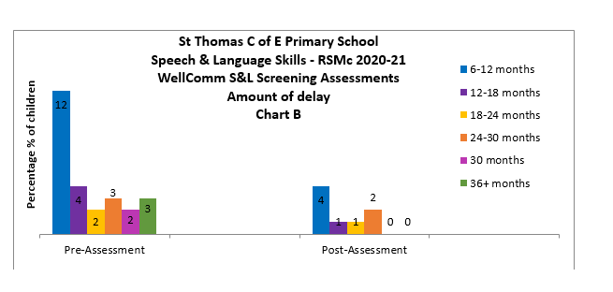
As you can see from the chart, 4 children were 6-12 months behind ARE for speech and language and 4 others are 18-36 months behind.

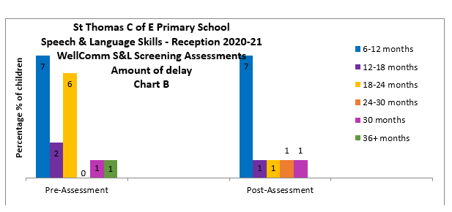
7 children are 6-12 months behind ARE and 4 between 18 months and 30 months, all of which have other underlying issues.

Objective 3 To ensure that all PP children who require support with their speech and language will have immediate support from September EYFS from a Speech and Language Therapist.
Action Implementation- Initial home visit by the class teacher at the beginning of the year will monitor which children are at 1-2 word level. This will be the target group of children initially.
Referral forms will be done by class teacher to keep a record of entry and exit data.
Rationale At foundation stage the gap analysis between PP and non PP for GLD is -26.4. One of the underlying issues is the level of Speech and Language on entry into Reception.
Research (EEF) shows there is a moderate impact for high cost in Early Years Intervention, though there is a specific need for SAL referral for our children. Further research indicates that there is a high need for SAL referrals in this area. Our own data indicates that only 33% of children have come in to Nursery with age appropriate language.
Success Criteria End of year data will show the impact of SAL therapist. All children who require therapy will have a programme to work on at home and at school
Date |  | Person Responsible |  | Monitoring and evaluation |  | Cost
Sept 2020 |  | DW  SMc  KM  SALT Therapist |  | DW/SM will refer children initially to the therapist via SENCo, who will refer to therapist after gaining permission from parents. SALT will see individual children in school with parents and set out a plan for school and parents to work with.  Interim review in Spring |  | £15000

Note September 20- Hannah Clarke (SALT) is currently working in Early Years every Wednesday to catch up with children that should have been seen in the spring/summer 2020. She has spent time in both Reception classes and will be working in Nursery at the beginning of October. Reports and resources have been written and distributed to parents and class teacher. However due to COVID all staff are working in bubbles which means the staff within the bubble need to implement the speech and language pack. This is difficult when there are several children in a class who have varying difficulties with their speech.
Impact of Objective 3 December review 2020-
April Review 2021 –.
Hannah is now back in school, working one day a week. She is currently working with year 1 children.
July review 2021- see wellcomm data above

Objective 4: FSW is employed for three days a week to support the families of our children with parenting, appointments, social and emotional issues.
Action The FSW will communicate with our EAL families, leading to all families having a good supported relationship with school. The FSW will provide targeted focused support. FSW based in class where there is the most need for family support due to covid. The FSW will work with the same class for a half term in line with Covid risk assessment,
Rationale Many of our families require support from school. Often a CAF is opened in order for school to manage the agencies who are working with the families. The FSW will be able form relationships with parents helping them to establish goals and routines at home and address barriers to learning for their children.
Success Criteria
FSW will report regularly on CPOMS the families she is working with. She will liaise with PWC and SENCo. A conclusive record of the conversations had, the work done with parents and children will be kept. Documents used and evaluated will be stored in the documents vault on CPOMS
Date | Person Responsible | Monitor and Evaluation | Costs
Sept 2020 | GA/CM/YA | GA will line manage FSW  GA to oversee 3 day time table.  Support FSW when required  Set half termly targets for FSW  Support FSW with training needs and liaise with YA | £15000

Impact of Objective 4-
December Review 2020
Families are receiving support from FSW. It has not been possible to work with families in their homes due to COVID. However FSW has kept in touch via zoom or TEAMS. She has supported SENCo and SGL and families translating during meetings
April Review 2021-
Timetable of work with families has been drawn up with SGL and FSW. This timetable of work has been shared with PP coordinator. It is too early to comment on the impact of her work as we have only been back in school fully for a month. The impact will be sought further in July.
July Review 2021- FSW continues to liaise with our most vulnerable families. Home visits resumed in May/June.The well being of our children and their families is carefully monitored and recorded on cpoms. Any advice given, strategies given to help with parenting are all recorded on cpoms. Attendance remains in the mid 90%. Need to clarify with RB.

Objective 5 Increase the number of Pupil Premium children reaching National Average in Reading end of Key stage 1 and Key stage 2.
Action - Provide opportunities to develop and acquire vocabulary in a variety of situations and environments.
Providing warm and inviting reading areas for our children to read in class
Ensuring our children have devices at home to access SPAG, Oxford Owl, and have further opportunities to read for pleasure and extend their vocabulary through life experiences.
Resources will be bought to enhance language development and reading
Rationale Good literacy skills provide us with the building blocks not just for academic success, but for fulfilling careers and rewarding lives. Yet despite our best efforts, a disadvantaged child in England is still more than twice as likely as their classmates from more advantaged homes to leave primary school without reaching the expected levels in reading and writing. (Kevan Collins 2017 EEF)
Success Criteria - Base line assessment for reading was done in Sept 2020 after 6 months of lock down- 30% of PP children reached the national average (NA) in years 1-6. The target is for 58% of PP children across years 1-6 to reach the national average in reading.
Below the year groups are broken down into individual year groups.
58% PP children in year 1 to reach national average(NA) by end of year, 60% PP children in year 2 to reach NA by end of the year, 50% PP children in year 3 to reach NA by the end of the year, 40% PP children in year 4 to reach NA by the end of the year, 54% PP children in year 5 to reach NA by the end of the year, 68% PP children in year 6 to achieve NA by the end of the year.
Date | Person Responsible |  | Monitor and Evaluation | Costs
Sept 2020 | Class teachers 1-6  Discussion with KM re strategies and resources |  | PIRA Autumn 2020  PIRA Spring 2021  PIRA Summer 2021  SATS Yr 2 and Yr 6  Strategies recorded on edukey provision map | £ 10000
Impact of Objective 5-
December Review 2020
Catch up curriculum implemented
April Review 2021
Lockdown for 6 weeks after Christmas. Now back in school a month. See previous scores on target 1 for PIRA
July Review 2021 71% of PP at ARE in year 1, 78% are at ARE in year 2, 87% of PP at ARE in year 3, 45% at ARE in year 4, 64% at ARE in year 5 and 74% of PP at ARE in year 6
Objective 6 To provide the PP children who require it a nourishing meal before the beginning of the school day, therefore enabling them to learn more effectively.
Action
A reliable adult will be employed to run the breakfast club.
A register will be taken every morning to keep a track who is attending.
Rationale The body needs nourishment in order for learning to take place effectively. There is also an opportunity for wake and shake activities to prepare the children for the day ahead.
Success Criteria
Breakfast club will be well attended by PP children and non PP children
Date | Person Responsible |  | Monitor and Evaluation | Costs
Sept 2020 | CM/YA |  | Register taken every day  Mrs P will ensure that all children eat an appropriate amount and behave in an appropriate manner
Impact of Objective 6-
Note – there are currently 75 breakfasts eaten each week in breakfast club, non of which are PP.
December Review 2020
April Review 2021-
Check to see if any PP children are accessing breakfast club
July Review 2021- PP children not accessing breakfast club- reason- parents are at home not necessarily going out to work
Objective 7 To track the progress of PP children through termly assessments of PIRA, PUMA and GPS.

Action Assessment weeks are planned well in advance in the school diary. The assessments are strictly adhered to by the class teachers.
Rationale The PiRA and PuMA GPS tests work with children and teachers and they get feedback very soon after the tests have been completed. EEF state that feedback has a high impact in helping children to learn.
Success Criteria
Teachers, parents and children can see where strengths and areas for development lie and can adapt the work appropriately. Parents will have a clear idea where the children are working and will have a clear understanding how to help their children
Date |  | Person Responsible | Monitor and Evaluation | Costs
W/c 18TH Nov  W/c 2/3/20  W/c 4/5/20  (yr2-6) |  | KM | KM will liaise with the class teacher the success/RFI of each PP child. After each analysis a programme of provision will be implemented on a termly basis | £4000
Impact of Objective 7- see target 1

Objective 8
To give our most vulnerable PP children the facility to reflect on their emotions, express gratitude and think about their actions

Action: Happy Self Journals will be introduced to the appropriate children by the PWC.

Rationale A daily journal for children aged 6 to 12, based on scientifically proven methods that promote happiness, develop healthy habits for life and nurture enquiring minds. Beautifully illustrated and easy to use, with just a few minutes focus each day, children benefit by being encouraged to express gratitude, reflect on their emotions and think about their actions.
Keeping a gratitude journal is one of the most well-established happiness practices and the easiest to do. Practising gratitude is central to the journal and a simple introduction to the concept encourages children to reflect on three positives of their day. Research has shown that practising gratitude through a journal increases a sense of happiness as well as a range of physical, psychological and social benefits including stronger immune systems, higher levels of positive emotions and being more helpful, generous and compassionate. Practising gratitude not only helps children see the goodness in their lives but also that this can come from a number of sources.
Growth Mind-set- this is a term introduced by Prof Carol Dweck and a concept that many schools are now introducing as a way to support a positive learning mind-set. Those with a growth mind-set (as opposed to a fixed mind-set) believe they can improve with hard work and perseverance and that their intelligence isn’t fixed. They display better self-esteem and increased resilience. The journal encourages a growth mind-set through checklist prompts and use of daily quotes to remind children about the importance of not giving up when faced with challenges.
Mindfulness- Studies with children show that behaviour leading to the enhanced welfare of others promotes increased physical and mental wellbeing. The journal encourages this in a number of simple ways through random acts of kindness, reflecting on who they were kind to (or who was kind to them) and prompts them to help others in a variety of different of ways.
Digital wellbeing- Time spent using the journal is an analogue antidote to screen time. Children are becoming increasingly distracted by social media and online games, activities that are proven to contribute to stress and other mental-health problems. The journal encourages family dialogue on this topic through numerous prompts for screen-free activities.
Self-awareness- Diversity of emotional experience is scientifically linked to happiness and dispels the myth that happiness equals a perpetual state of positive emotion. Cultivating self-awareness and allowing children to show true emotions is therefore beneficial. The journal supports this in a number of ways by prompting children to think about their emotions on a daily basis.
Success Criteria The children who receive one of these journals be closely monitored by the PWC. She will determine how the journals are impacting on the pupils well being
Date | Person Responsible | Monitor and Evaluation | Costs
Sept 2020 | GA/FSW/KM | Regular meetings will be timetabled with the children to target areas of concern. The children will be given the opportunity to reflect on what they have written in their journals. | £180
Impact of Objective 8 –This objective was on the PP plan last year, however due to COVID this is going to be kept as a target to ensure our most vulnerable PP children have a voice. Throughout the year children had support from the well being support assistant. Session were timetabled so that children could discuss their concerns in groups. Children were not encouraged to bring the journals into school, this was to avoid any contamination of COVID from home to school and vice versa. Most of the children targeted for this support developed good social skills, made stronger bonds between friends and learned to listen to each other.

Objective 9: To provide resources for children which will support them in their learning- for example revision guides for year 6. Teachers to highlight any resources required to improve the outcomes for our PP children
Action: Class teachers to liaise with PP coordinator, listing children and resource required.
Rationale All PP children will have the required resources to support their learning in class.
Success Criteria All PP children will have access to resources which they will be able to use at home and at school. Progress will be measured via SATS, PIRA, PUMA, GPS

Date | Person Responsible | Monitor and Evaluation | Costs
Sept 2020 | DMe/SK  To order/implement revision guides DMe/SK | DMe/SK/KM  Impact of revision guides  Practice guides- Reading Grammar and Maths  Booster Guides  Maths Balance (yr1)  Double sided Maths counters (yr1)  Magnetic letters  Phonics tile for outdoors  Teach me phonics tags  Resources required- Social Skills Games  Lego Brick set 884 pieces | £ 300  £10.73  £20.99  £17.95  £52  £15  £17.99  £45.95
Impact of Objective 9- December Review 2020  Year 6 revision guides will be provided in year 6 in January 2021- impact will be noted after SATS results  - Year 6 80% of PP are at ARE or above in writing  73% of PP are at ARE or above in reading  66% of PP are at ARE or above in maths |  |  | Total to date  £103,232.61

